Global Development of the Solar Cycle
as Found from the Nobeyama Radio Observations

G.B. Gelfreikh et al.
Central astronomical observatory at Pulkovo of RAS, St.-Petersburg, Russia
gbg@GG1623.spb.edu

Abstract

The theory of physical nature of the solar activity and its cyclicity needs an analysis of different types of its appearance over the whole disk of the sun. For a long time, study of the 11-year cycles was based mainly on observations of the active regions at low heliographic latitudes. It is obvious, however, that the cycle is a global process and needs the knowledge at least of the magnetic field over the whole solar surface. More than that, it was found in some studies (e.g. by V. I. Makarov et al.) that oscillations of the faculae in the polar zone activity in some 5 or 6 years later are repeated in the main activities at lower latitudes of the next 11-year cycle. That implies that the real duration of a cycle in fact lasts about 17 years, and two successive cycles do overcome each other. The other problem of interpretation of the nature of solar cycles is the obvious necessity to study it at all levels of the solar atmosphere. Today we do posses brilliant pictures of the solar corona obtained from space laboratories in EUV and X rays. However, no bank of such observations include data necessary for homogeneous analysis of 11-year cycle. The main reason is the time limitations of working conditions of such instruments. The radio data, however, could be the solution of the problem. At present stage, however, only the Nobeyama radio heliograph is capable to present the necessary information. The point is that only it presents high quality homogeneous 2D mapping of the whole sun with reasonably high spatial resolution of about 10 arcsec. It is especially so, if it will work at least to 2008, when the present 23-d solar cycle will come to an end.
The radio maps of the sun at wavelength 1.76 cm made with the NRH made it possible to investigate the following parameters of the progress of the cycles:
- Development of the flocculae/faculae regions at all heliographic latitudes;
- Sunspots with the high magnetic field strength at low corona levels;
- Magnetic strength and structure of the active regions at the level of the upper chromosphere;
- Development of differential rotation of the sun;
- Filament and prominence development in the solar cycle;
- Quasi-periodic oscillations of the plasma structures of the solar atmosphere;
- Neutral line enhancements in ARs reflecting coronal arches structure.
In this report the illustrations of the above method of investigation of the solar activity and its development are demonstrated and some samples of analysis of the 11-year solar cycles are shown. The problems and possible ways of developments of investigations of the solar activity and its 11-year cycle are discussed.

Introduction

Modern physics of the sun is still in the stage of developing the nature of the solar activity, including the problem of the solar cyclicity. This study is important for understanding the physical nature of such processes both at the sun and the stars, and also for the practical problems of forecasting the space weather and other forms of the influence of the sun on the human activity. For effective study of solar physical processes we certainly need to observe and make diagnostics of the plasma parameters at all levels of the solar atmosphere. Though the observations from cosmos have made possible to register plasma structure in the corona, the radio observations did not loose their role in these problems. Complex studying of activity of the Sun allows us to restore fuller picture of excitation of magnetic field inside the Sun and to study properties of weak magnetic fields, especially in the corona. The basic properties of solar cyclicity in a radio range have allowed to establish use of regular observations of radio heliograph Nobeyama. So, presence of polar activity in a radio range, has been confirmed, speed of differential rotation is determined and torisional waves are revealed during. The methods of studying magnetic fields of active areas based on the polarization measurements of radio emission have got further development. Regular observations of polarization on radio heliograph Nobeyama allow carrying out estimation of distribution of polarization of all disk of the Sun on different phases of solar activity.
In this presentation we made a short overview of the results found from the Nobeyama radio heliograph with more attention to the latest attempt to study global polarization analysis, the latter reflecting developing of the solar magnetic cycle. The programs for future analysis of the solar cycle are discussed.

Methods of analysis

In analyzing development of the solar activity we refer to brightness and polarization maps obtained at NRH at the wavelength of λ =1.76 cm. The initial data for the analysis were the daily data on circular polarization (R-L) and intensity (R+L) of the radio heliograph Nobeyama, presented in fits a format. The images received with 1 second accumulation of a signal were mostly used. Averaging the images received within day with periodicity of 10 minutes has been applied for each day of observation. Besides it, the received row has been subjected to procedure of a filtration. For this purpose as criterion of a level of noise it was calculated average polarization above a disk of the Sun. Images in which polarization in a corona at height 1.1R exceeded some threshold size of ~100 units of temperature were eliminated. Calculation of polarization was carried out at the disk of the Sun at distance from the central meridian no more than on 60º. Thus, matrixes of monthly average values of polarization in a latitude band +/-80º degrees have been generated. For the analysis of polarization of different kinds of activity procedure of definition of polarization also was applied to elements with various brightness temperatures. For this purpose the data of polarization were defined at joint processing images of polarization and intensity of a radio emission. During 1992-2003 ~3900 days of observation have been processed.

Structure of active regions

The presence of the solar active regions is most effectively registered at polarization maps. To determine some conditional idea of an active region we have chosen bright elements with brightness temperature exceeding 200 K and the surface area exceeding 5000 millionths of the solar hemisphere. Monthly averaged values of the number of such ARs observed on the sun is shown in figure 1 as the function of the helio latitude and time (years 1992-2002).

Figure 1. Distribution of the number of the bright elements on polarization maps ($T_b > 200 K$) with area exceeding 5000 m.hs (millionths of the hemisphere area) as function of helio latitude and time (years).

At the picture one can easily see many forms of development of the solar cycle. In the years 1992-1994 we see the latest stage of the previous 22-d cycle with the two main heliogrphic regions of the highest activity. Near the minimum period of 1995-1998 we see the shift of activity higher latitudes. So, beginning the year of 1998 the drift of ARs to the lower latitudes began.
Using this method we do not register high solar activity near the pole regions at the minimum phase of the cycle. This, however, become evident while using the other way of averaging observations (see figure 6), we will discuss later.
On polarization picture of development of the ARs with illustration of the sign of polarization (figure 2) we can follow the development of the inversion of direction of the magnetic field structures. In this case more presentative form was based on the areas of polarized regions (instead of their numbers). The polarization of the discussed plasma structures is mostly that of the bremsstrahlung emission. The degree of polarization is determined by the formula

$$
P%=n \frac{f_B}{f},
$$

where $f_B$ is gyrofrequency of electrons and а – frequency of observations. The spectral index $n$ represents the gradient of temperature in the region of formation of the radio emission. Generally one can expect that most of the active regions are bipolar structures. So, the two polrities in polarized emission should compensate. We may mention at least two important reason, why this is not the case. (1) The bipolar structures of the active regions are not symmetrical (different $n$ and $I$ parameters in the above formula). (2) The magnetic field of the ARs are partially connected with the global one. We need much more study to choose the correct conclusive answer to the problem.
Figure 2. Distribution of the area (millionths of the hemisphere area) of the bright elements for the two signs of the circular polarization as function of heliogpheric latitude and time (years).

The figure 2 presents a good illustration of development of the active magnetic structures at most latitudes (up to 70 deg.). However the inversion of the polar magnetic field connected with the global (“quiete”) magnetic structure is not demonstrated by this method. We conceder that later.

Differential rotation

It is well known that the law of differential rotation varies during the solar cycle resulting in so called torisional mode. The interpretation of its laws is an important problem while developing the theory of the solar cyclisity and the general nature of the solar activity. Figure 3 demonstrates the results of an analysis of the differential rotation of the sun found from observations at wavelength λ=1.76 cm of the Nobeyama radio heliograph. To find velocity the correlation method of the radio brightness was used.
The figure shows the rotation velocity around the solar equator as function of time (years). The character of the curve shows a clear function dependence demonstrating the high accuracy of the radio method. Minimum of the velocity near the years of 1998-1999 is the époque of the growth of the solar activity in the 23d cycle.
.
Figure 3. Variation of the rotation velocity of the equatorial ($\pm 10 deg$) zone of the sun as function of time (years) as found from the Nobeyama heliograph observations.

To study the appearance of torisional waves in radio wave range similar a analysis have been made for all heliographic latitudes. The result is shown in figure 4. Typical for torisional waves propagations of the deflections from mean velocity from higher latitudes to the lower ones is also demonstrated at radio observations
Figure 4. Development of the differential solar rotation as the function of the time (years) according to Nobeyama heliographic observations. Darker regions belong to lower velocities.

Prominences and filaments

In investigations of cycles of the solar activity prominences and filaments are used to find the lines separating the regions of different magnetic polarities. This refers even to weak global magnetic fields of the sun. In most studies they use the observations made in the chromosphere H_{α} line of the hydrogen. So, using this type of observations made in India, V.I.Makarov managed to restore development of the global magnetic field for the whole hundred years. In case of Nobeyama data (see figure 5 ) we deal with independent approach to this method of analysis. Important point here is that the cm radio waves may be more sensitive to the presence of the cold plasma in the solar corona than optical H_{α} maps and more directly represent parameters of the thermal plasma. However, the degree of correlating of the two methods still needs an analysis.
From the figure 5 one can see variations of the development of prominence activity during the solar cycles. The maximum of the number of the prominences obviously coincide with the maximum number of active regions at lower altitude. They are obviously belong to the neutral lines inside the the ARs. During the development of the cycle their position is shifting to the equator as do the ARs.
At the same time we see the tendency to move the position of prominences to the pole regions (another branch). This reflects the motion of the neutral lines of the global magnetic fields at the proper phase of the 11-year cycle.

Figure 5a. (Top) Number of the prominences as function of the heliographic latitude and time (years}.

Figure 5b. Area of prominences as the helio latitude and time (years).

Global magnetic structure

Earlier in this presentation we analyzed the distribution of polarity of a radio emission considered as weak ARs. This time we analyze the polarization observed over the whole surface of the disk (inside +/- grad helio longitedes) with possible maximum averaging procedure. The latitude-time diagrams of distribution of circular polarization of a radio emission were constructed for the period of 1992-2003. Procedure of averaging has been applied for reduction of noise under several images for a day and a filtration of noisy images The analysis of distribution of polarization for structures of various brightness temperature has been carried out.
The distribution of the amplitude of tye polarized signal is shown on figure 6 as function of the
time for the elements having brightness temperature not less 11000ºК. It is possible to note, that
he basic sources of polarization are sunspot. But also, bright polarized regions are present at high
latitudes. The maximum of the solar activity at high altitudes is actually present near the period
of minimum at lower helio latitudes. Also, one can notice that some variation of the polar
activity is repeated in time some 5 or 6 years later at lower latitudes. The latter effect (known
from optical observations) certainly needs a detailed analysis.
To estimate the contribution of various elements to polarization of background magnetic fields, we had carried out calculation of polarization above the areas having various brightness temperatures. On fig. 8 distribution of polarization for areas with яркостной in temperature above 11000K is presented.
Most precisely, here zones of formation of spots are allocated. Wings of "butterfly" of polarization in the band of sunspots formation have an opposite sign. Probably, it occurs because polarization from leading spots in solar groups prevails. On fig. 4 distribution of polarization for areas with temperature below 11000K is presented. On that diagram, area of formation of sunspots is not allocated. During too time in northern hemisphere the zone of negative polarization drifts from middle latitude to a pole within 1992-2000. In a southern hemisphere the zone of negative polarization drifts to a pole during 1998-2001. Probably, it can be interpreted as follows. Drift of filaments which polarization has mainly negative polarization is imposed on drift of polarization of background magnetic fields.

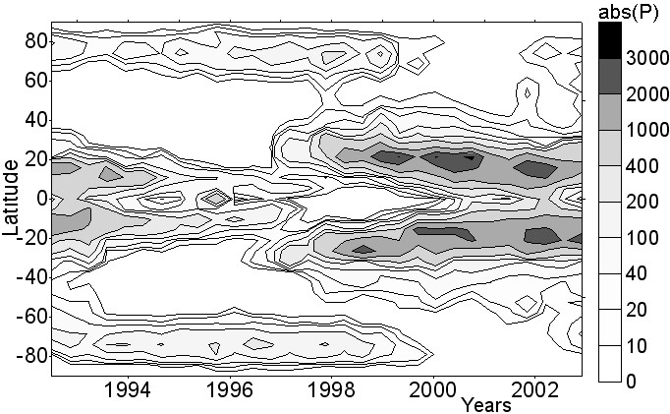
Fig. 6. Distribution of absolute value of polarization of a radio emission of 17 GHz, determined for the elements having brightness temperature higher 11000К

The direction of a magnetic field will determine a sign of circular polarization. On fig. 7 latitude-time distribution based on averaged polarization maps is presented. For the best allocation of background magnetic fields on these diagram areas with values above 200 K in terms of brightness temperature were not taken into account. Various colors here present areas from prevailing polarity of the right or left polarization. It is possible to note, that distribution of polarization depends on a cycle of activity not only in the region of formation sunspots, but also in high-altitude areas.

With the beginning of 23-rd cycle of activity during 1996-2000 drift of polarization of an opposite sign to poles is observed. The phase drift in polarization of a radio emission is close to drift of neutral lines during reversal of a large-scale magnetic field.

To estimate the contribution of various elements to polarization of background magnetic fields, we had carried out also calculation of polarization above the areas having various brightness temperatures. On fig. 8 distribution of polarization for areas with brightness temperature above 11000K is presented. In this case the zones of formation of spots are most obviuous. Wings of "butterfly" of polarization in the band of sunspots formation have an opposite sign. Probably, it occurs because polarization from leading spots in solar groups prevails.

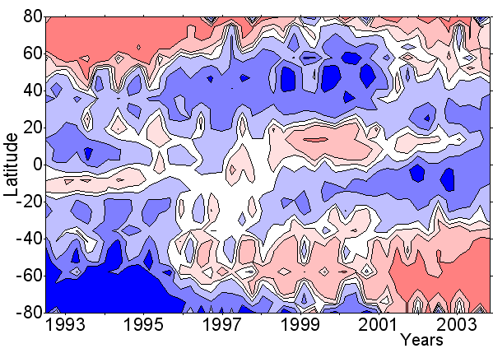
Figure 7. The latitude-time diagram of distribution of polarization of the radio emission, received under the daily synthesized images, on the basis of 10 minute data Nobeyama. Areas with a level polarization are higher 200º Tb are excluded.
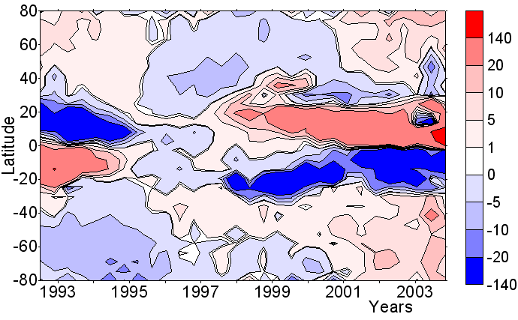
Figure 8. The distribution of polarization received above areas with brightness temperature is higher 11000К

Future development

As we have illustrated above, the radio maps of the sun at wavelength 1.76 cm made with the NRH made it possible to investigate the following parameters of the progress of the solar cycles:
- Development of the flocculi/faculae regions at all heliographic latitudes;
- Sunspots with the high magnetic field strength at low corona levels;
- Magnetic strength and structure of the active regions at the level of the upper chromosphere;
- Development of differential rotation of the sun;
- Filament and prominence development in the solar cycle, reflecting the development of the global magnetic field.
In this report the illustrations of the above method of investigation of the solar activity and its development were demonstrated and some samples of analysis of the 11-year solar cycles shown.
Important point of these studies is that the proper radio observations are capable to analyze most of the types of the solar activity, which were earlier found from observations in a number of different wavelength ranges. Analysis of the strength of the coronal magnetic fields is made mostly using radio observations. The Nobeyama radio heliograph is an effective instrument to solve these problems. The absence of detailed spectral analysis is certainly the weak point of the Nobeyama but the coordinate observational programs with the radio heliograph at Badary (SSRT) and the RATAN-600 observations significantly improve the situation. For study of the nature of the solar cycle is specially important point is the 12 year period of regular observations at Nobeyama. However this period in fact is not enough for analyzing the nature of the solar periodicity.
The point is that, however, the 11-year periodicity is clearly registered in solar observations, the real length of one section of the cycle is longer, probably about17 years (Makarov et al.). So, it for developing the nature of the solar cyclicity it is essential to look for the development of the present 23-d cycle till its end, somewhere in the year 2008. In spite of a lot of work to find the physical nature of the solar cyclicity we are far from satisfactory decision of the problem.

The work was carried out with support of grant of RFBR 02-02-16548, programs of the RAS "Astronomy", "Integration" (I0208.1173).

Literature

1. G.B. Gelfreikh,
Coronal magnetic field measurements through bremsstrahlung emission. In the book
“Solar and Space Weather Radiophysics”. Kluwer Academic Publishers. 2004.

Gelfreikh G.B., Makarov V.I., and Tlatov A.G.
Modern Understanding of the Solar Aсtivity Cycle as a Global Process from Optical and Radio Observations.
Phys. Chem. Earth. 2000, v.25, No.5-6. Pp.437-440.

Gelfreikh G.B., and Shibasaki K.
Radio Magnetography of Solar Active Regions using Radio Observations.
Proc. 9th European Meeting on Solar Physics, “Magnetic Fields and Solar Processes
(ESA SP-448, December 1999). Pp.1339-1443.

Grebinskij A., Bogod V., Gelfreikh G., Urpo S., Pohjolainen S., and Shibasaki K.
Microwave tomography of solar magnertic fields.
Astronomy and Astrophysics, Supplement Series. 2000, V.144. Pp.169-180.

G.B.Gelfreikh, V.I.Makarov, A.G.Tlatov, A.Richokainen, and K.Shibasaki.
A Study of the developmentof the global solar activity in the 23-rd solar cycle based on radio observations with Nobeyama radio heliograph.1. Latitude distribution of the active regions and dark regions.
Astronomy and Astrophysics. 2002

B.Gelfreikh, V.I.Makarov, A.G.Tlatov, A.Richokainen, and K.Shibasaki.
A Study of the developmentof the global solar activity in the 23-rd solar cycle based on radio observations with Nobeyama radio heliograph. 2. Dynamics of the differential rotation of the Sun.

Tlatov A.G., Shramko A.D., conf. "Solar activity ..”, Sn-Petersburg, 2002, p.559-567

